Instruction on completing the harmonised format for the Declaration of Conformity for Design, Construction and Noise

A harmonised format for a Declaration of Conformity has been created as an answer to manufacturer’s and Notified Bodies requests for an interpretation of the statutory schemes.
Although this common format is not mandatory, its use is highly recommended. The document has been agreed by representatives from Member States and it provides all the essential information judged necessary to satisfy the market surveillance authorities in the EEA Member States.
The form is not intended to be used exactly as published but as an aid/checklist or model upon which manufacturers of recreational craft can formulate their own version.
The form can be customise by omitting unused sections and by using the own company layout. However it is important that the overall information and format is not changed too much to maintain common design.

Manufacturer and Authorised Representative details:
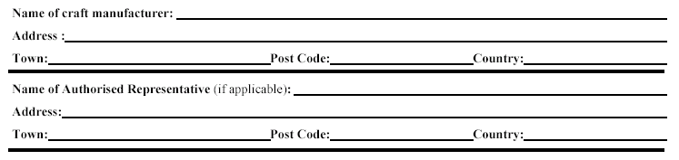
Manufacturer: The manufacturer is any natural or legal person who designs and manufactures a product or who has it designed and/or manufactured for him with the view to place it on the market.

Authorised representative: The manufacturer may appoint an authorised representative based in the Community to act on his behalf to carry out certain tasks required by the applicable Directive. However, a manufacturer established outside the Community is not obliged to have an authorised representative within the Community, although this may present some advantages.
The delegation of tasks from the manufacturer to the authorised representative must be explicit and should be in writing, in particular to define the tasks and the limits of the representative’s powers. The authorised representative may, for instance, affix the CE marking and draw up and sign the EC declaration of conformity.

Where a manufacturer has appointed an authorised representative their name and address should appear in the appropriate section. (If a manufacturer based outside the EEA does NOT appoint an authorised representative within the EEA, then the person responsible for placing the craft on the market must hold copies of all relevant compliance documents.)

If an authorised representative is not appointed, this part can be removed from the declaration.

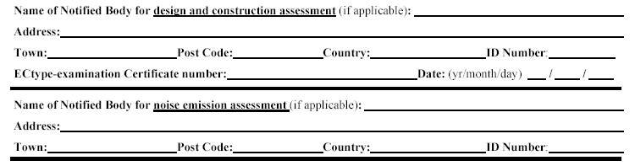
Notified Bodies details:

Details of the Notified Body (Bodies) can be removed when the manufacturer used self-assessment (internal production control - Module A) for construction and/or noise.

If a Notified Body has intervened in the production phase, (that is if one of the following modules has been used Aa, B+C, B+D, B+F, G and H), its name, address and identification number should be stated.
In addition, the EC type-examination certificate number for the certificate issued by the Notified Body (in case of module B+C, B+D, B+F assessment) should be provided.
The Notified Bodies details can be removed when the boat builder installs a stern drive engine with integral exhaust or the craft is designed to be powered by an outboard engine, as the sound assessment is under the responsibility of the engine manufacturer.

Module used:

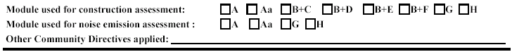
The modules used for conformity assessment, in accordance with Article 8 of the Directive shall be indicated. Only one module may be applied for each assessment (construction and noise). Also other directive applied to the recreational craft shall be listed. If no other directives are applicable, this line can be removed.

Description of the craft:
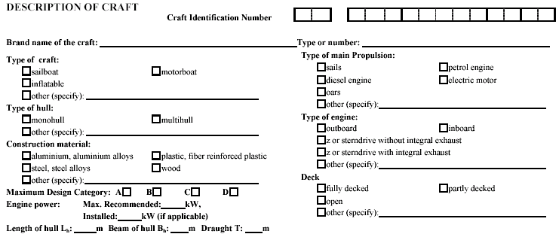
The description of the craft should contain the above stated information. Maximum recommended engine power is the maximum engine power recommended by the craft manufacturer. The installed engine power refers to the power of the engine that is actually installed. In case of outboard powered boats, this may not be applicable and can be removed. Length, beam and draught of hull should be measured in accordance with the harmonised standard “Principal data” (EN ISO 8666). The maximum draught Tmax shall be used.
Tick boxes or items which are not applicable can be removed.

The Declaration:

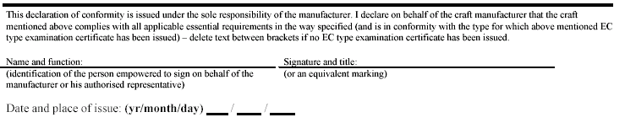
The Declaration of Conformity must identify the person empowered to sign on behalf of the manufacturer of the craft together with clarification of signature and the position held by that person. In the case where the manufacturer of the craft, in writing, has delegated the responsibility to sign the Declaration of Conformity to an authorised representative, the authorised representative should sign the document.
The signature could be stamped, printed, copied etc. but must always be given in such a way that the person empowered to sign could be identified.

The second side of the form:
For each essential safety requirement that applies to the craft, the details of the referenced standards or other normative documents against which compliance is declared should be given. It is important that the revision years of the standards are given. If reference is made to the Technical file, it is helpful indicate applicable page or chapters. Only those essential safety requirements that apply to the craft have to be shown on the Declaration of Conformity.
The essential requirements for noise emissions can be removed when the boat builder installs a stern drive engine with integral exhaust or the craft is designed to be powered by an outboard engine, as the sound assessment is under the responsibility of the engine manufacturer. When the craft is installed with an inboard engine without integral exhaust the lines for noise emissions shall be completed as follows:
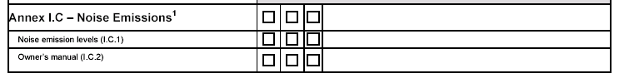
- Reference shall be made to either
  - the standards EN ISO 14509-1 (Pass-by test) or EN ISO 14509-2 (Reference Boat) – indicate tick box “Standard” or,
  - to the P/D ratio method – indicate tick box “Other normative document / method”.
- The tick box for “technical file” shall be marked and reference shall be made to either the P/D ratio calculation or the Notified Body’s test report in the Technical File.
- The tick box for “Other normative document / method” shall be marked and if an inboard engine without integral exhaust is installed, reference to the owners manual of the craft shall be given. If an outboard engine or Sterndrive with integral exhaust is installed, reference to the owners manual of the engine manufacturer shall be given.

